JUNIOR BOARD

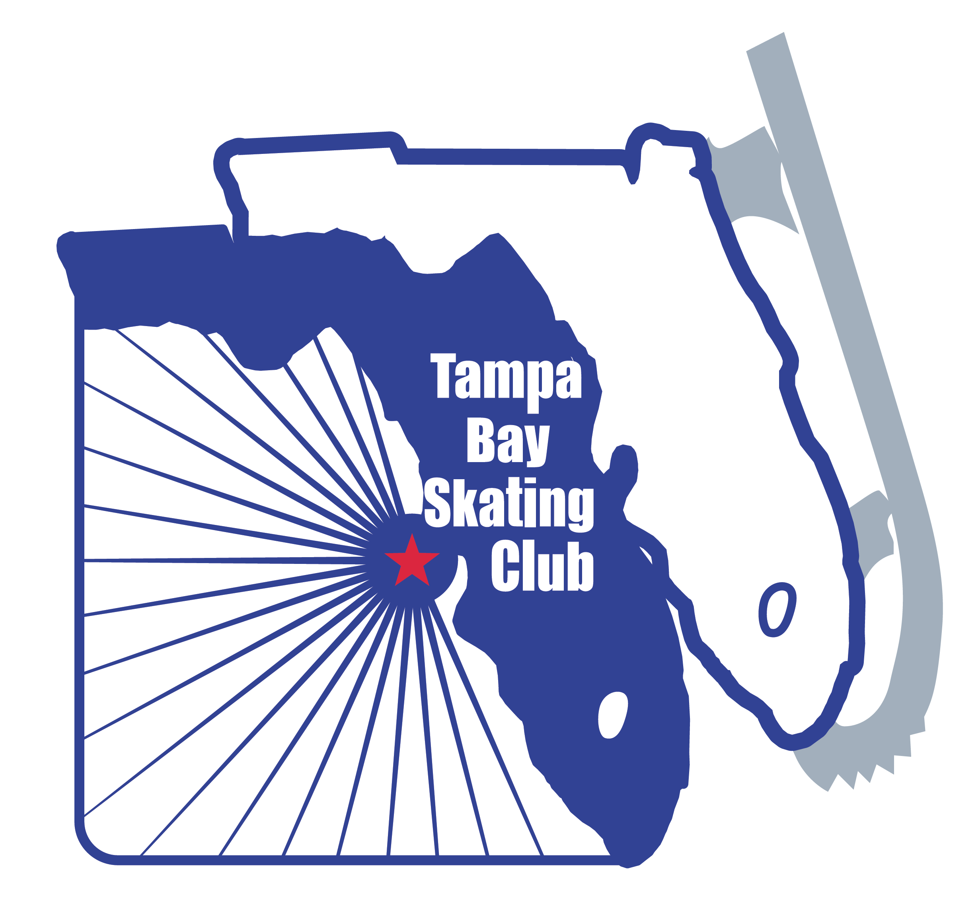
The 2023-2024 skating season will begin a new chapter for the Tampa Bay Skating Club with opportunities for our junior skaters that will promote fun and engagement. With the formation of the Junior Board, skaters will learn responsibility and the meaning of volunteerism, while enhancing positive character traits, strengthening friendships and becoming effective and active members of the Tampa Bay Skating Club. Activities include:

- Fundraisers
- Holiday Parties
- End of Year Banquet
- Skater Shout Outs
- Clinics and Camps
- Newsletter Updates
- Orange Blossom Volunteer

Requirements for the Junior Board:

Must be a member of TBSC | Between the ages of 8-18 | Able to commit to regular meetings for the Junior Board | Able to volunteer at Club-sponsored events.

*It is a crucial to understand the importance of being a leader and setting an example for other skaters*

If you are interested in being on the Junior Board, please complete the form below and email: tampabayskatingclub@gmail.com.

NAME__________________________________________________________AGE________

SKATING LEVEL_____________________________________________________________

PARENT NAME(S) ___________________________________________________________

EMAIL_____________________________________________________________________

CELL/TEXT_________________________________________________________________

PROVIDE A BRIEF INTRO ABOUT YOURSELF AND ANY INTEREST IN A BOARD POSITION _______________________________________________________________________________________________________________________________________________________________________________________________________________________________________________________________________________________________________________________________________________________________________________________

